**Lesson 7 Demo 5**

**Understanding Volume Snapshot Classes**



Steps to be followed:

1. Installing CSI Driver
2. Creating a volume snapshot class

**Step 1: Installing CSI Driver**

1. Run the following commands in series to change to the latest supported snapshotter version:

***SNAPSHOTTER_VERSION=v2.0.1***

1. Type the following command to apply VolumeSnapshot CRDs:

***kubectl apply -f https://raw.githubusercontent.com/kubernetes-csi/external-snapshotter/${SNAPSHOTTER_VERSION}/config/crd/snapshot.storage.k8s.io_volumesnapshotclasses.yaml***

***kubectl apply -f https://raw.githubusercontent.com/kubernetes-csi/external-snapshotter/${SNAPSHOTTER_VERSION}/config/crd/snapshot.storage.k8s.io_volumesnapshotcontents.yaml***

***kubectl apply -f https://raw.githubusercontent.com/kubernetes-csi/external-snapshotter/${SNAPSHOTTER_VERSION}/config/crd/snapshot.storage.k8s.io_volumesnapshots.yaml***

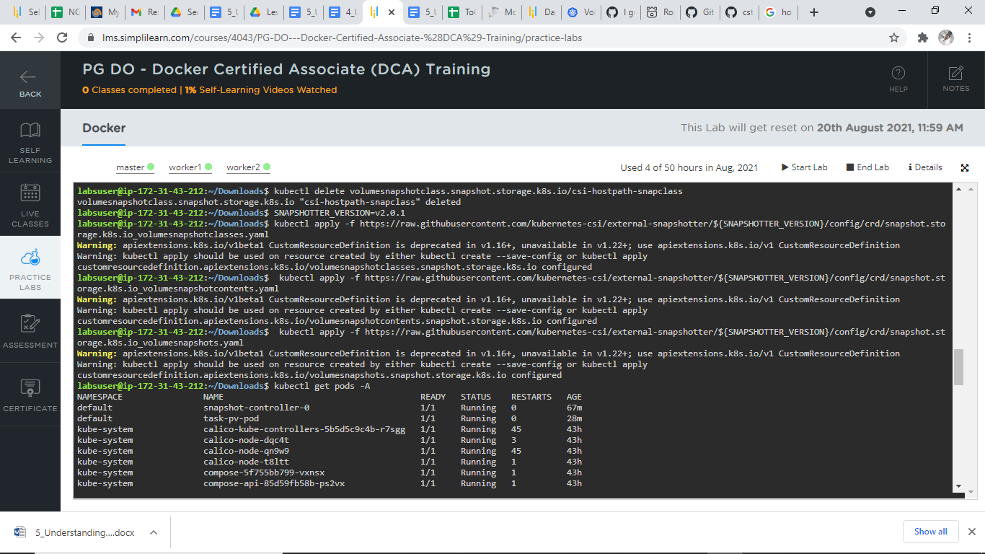

1. Create snapshot controller by using the following commands:

***kubectl apply -f https://raw.githubusercontent.com/kubernetes-csi/external-snapshotter/${SNAPSHOTTER_VERSION}/deploy/kubernetes/snapshot-controller/rbac-snapshot-controller.yaml***

***kubectl apply -f https://raw.githubusercontent.com/kubernetes-csi/external-snapshotter/${SNAPSHOTTER_VERSION}/deploy/kubernetes/snapshot-controller/setup-snapshot-controller.yaml***

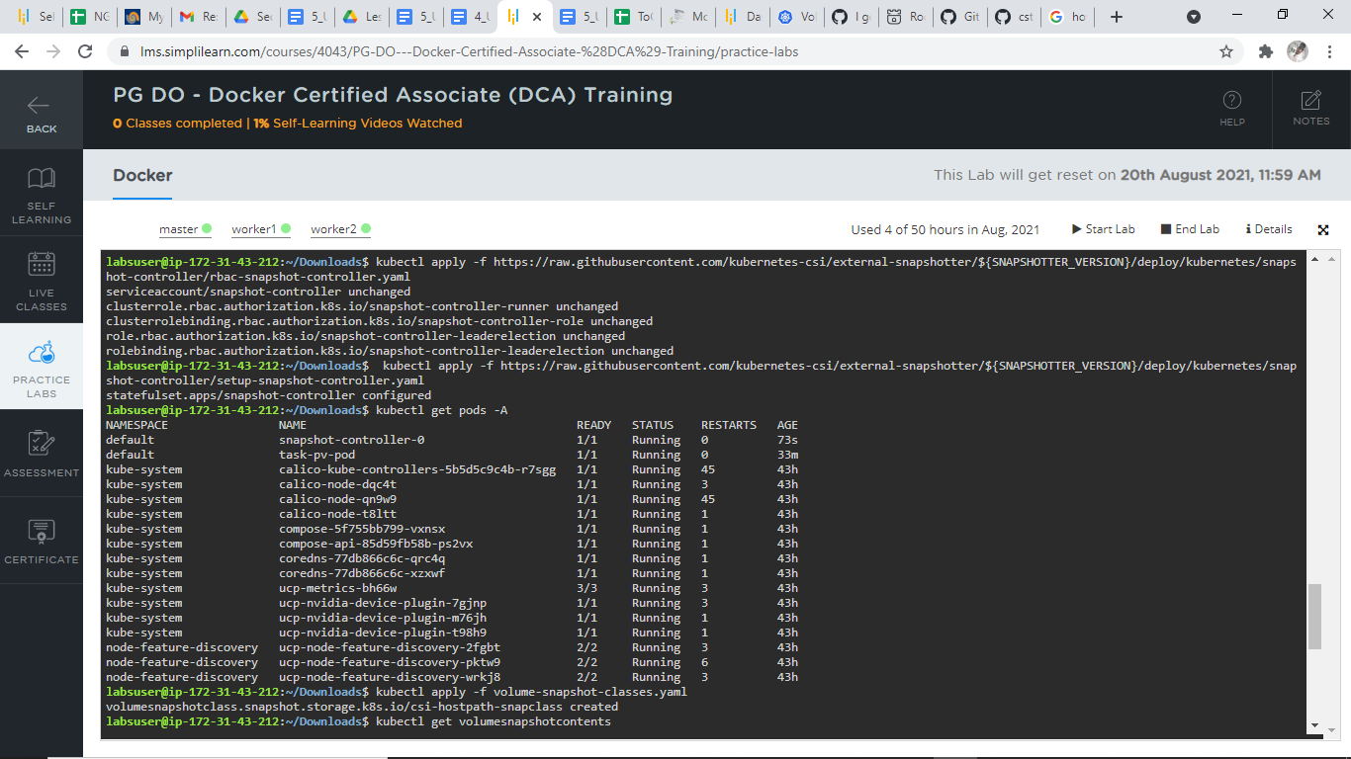

1. Type ***kubectl get pods –A:***



**Step 2: Creating a VolumeSnapshot Class**

* 1. Create the configuration file using the ***vi volume-snapshot-classes.yaml*** command and add the following code to the file:

***apiVersion: snapshot.storage.k8s.io/v1***

***kind: VolumeSnapshotClass***

***metadata:***

***name: csi-hostpath-snapclass***

***annotations:***

***snapshot.storage.kubernetes.io/is-default-class: "true"***

***driver: hostpath.csi.k8s.io***

***deletionPolicy: Delete***

***parameters:***

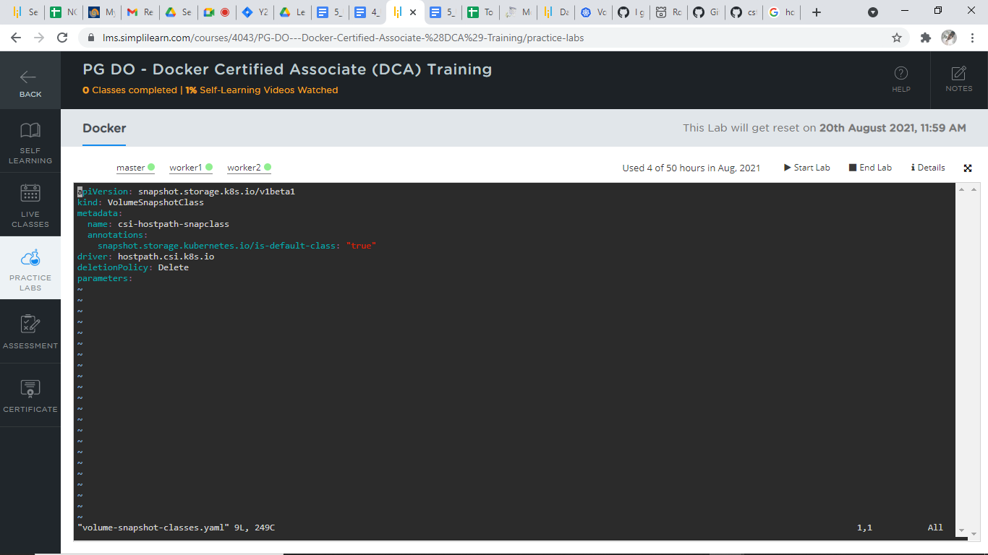

* 1. Create the resource using the below command:

***kubectl apply -f volume-snapshot-classes.yaml***

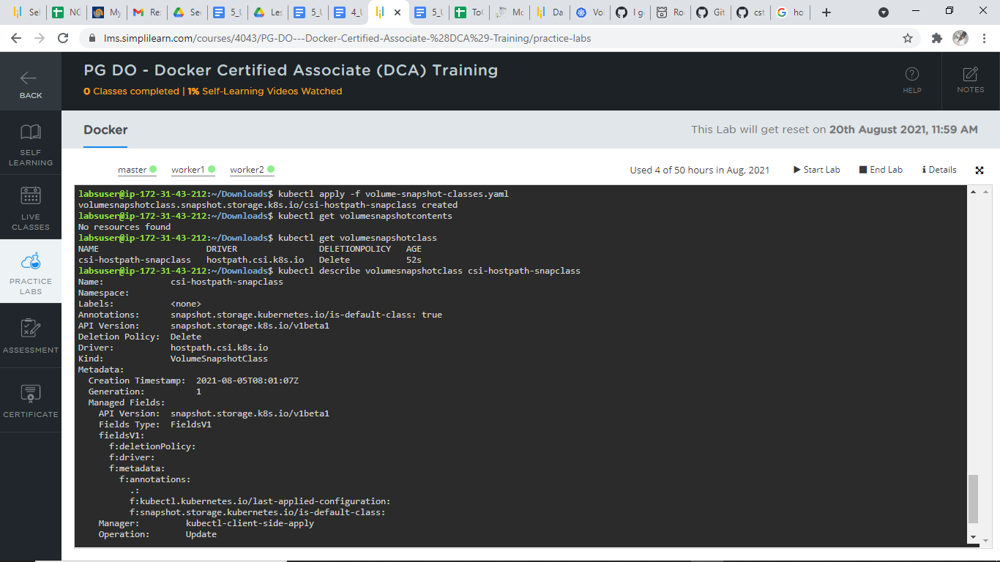

* 1. View the volume snapshot classes:

***kubectl get volumesnapshotcontents***

